Data analysis

According to our topic, we use python to analyzed the public art data from 3 different aspects, including the development of public art over time, geographical distribution and material usage.

It is showed that, in general, there are 152 public art in Edinburgh in total. The earliest one existed in 1685, called ‘Charles II’, which has a history of more than 300 years. Four public art existed in 2020, including ‘Scotland, together, persevere, NHS’,’ Free Speech’, ‘Unity’ and ‘The Protest’. After that, we analyzed more details about the development of public art in Edinburgh over time. It is illustrated by the bar chart, the 20th century saw the most public art established in Edinburgh, accounting for 40.1%. While public art before the 19th century made up only 1.3% of the total. From 18th century, the number of newly established public arts increased during each century. Although it is only the first decade of the 21st century, 43 new public art projects have been created, accounting for 28.3 percent of total.

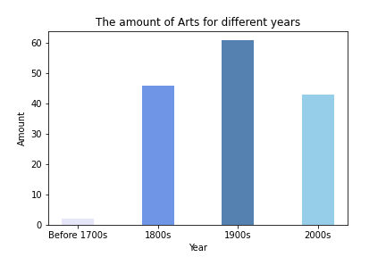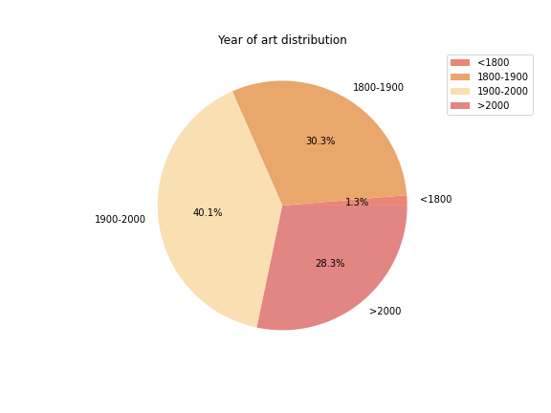

As it shown in the geographical distribution heat map and the location scatterplot, public art is not evenly distributed in Edinburgh 并具有相对聚集的特点（就是会一小堆一小堆的聚集在一起，我也不知道该咋描述，你可以形容一下） It is mainly concentrated in the city centre area in Edinburgh. 在公共艺术类型方面，数据集给予了我们对其公共艺术类型的相关描述，通过词云，我们可以发现，爱丁堡公共艺术的类型多样，最主要有sculpture, statue, stone, monument等

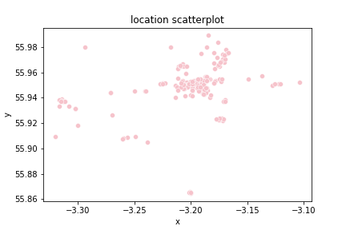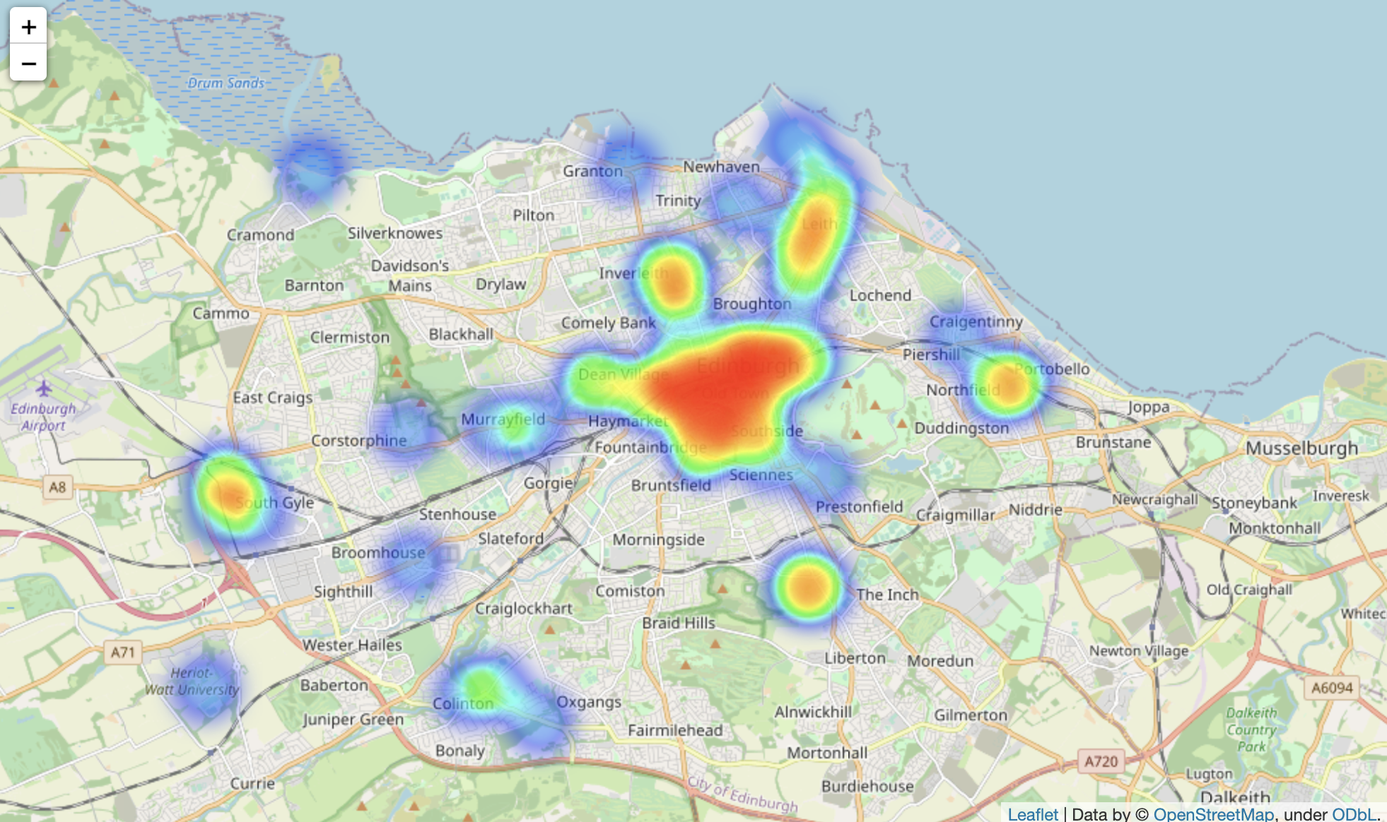

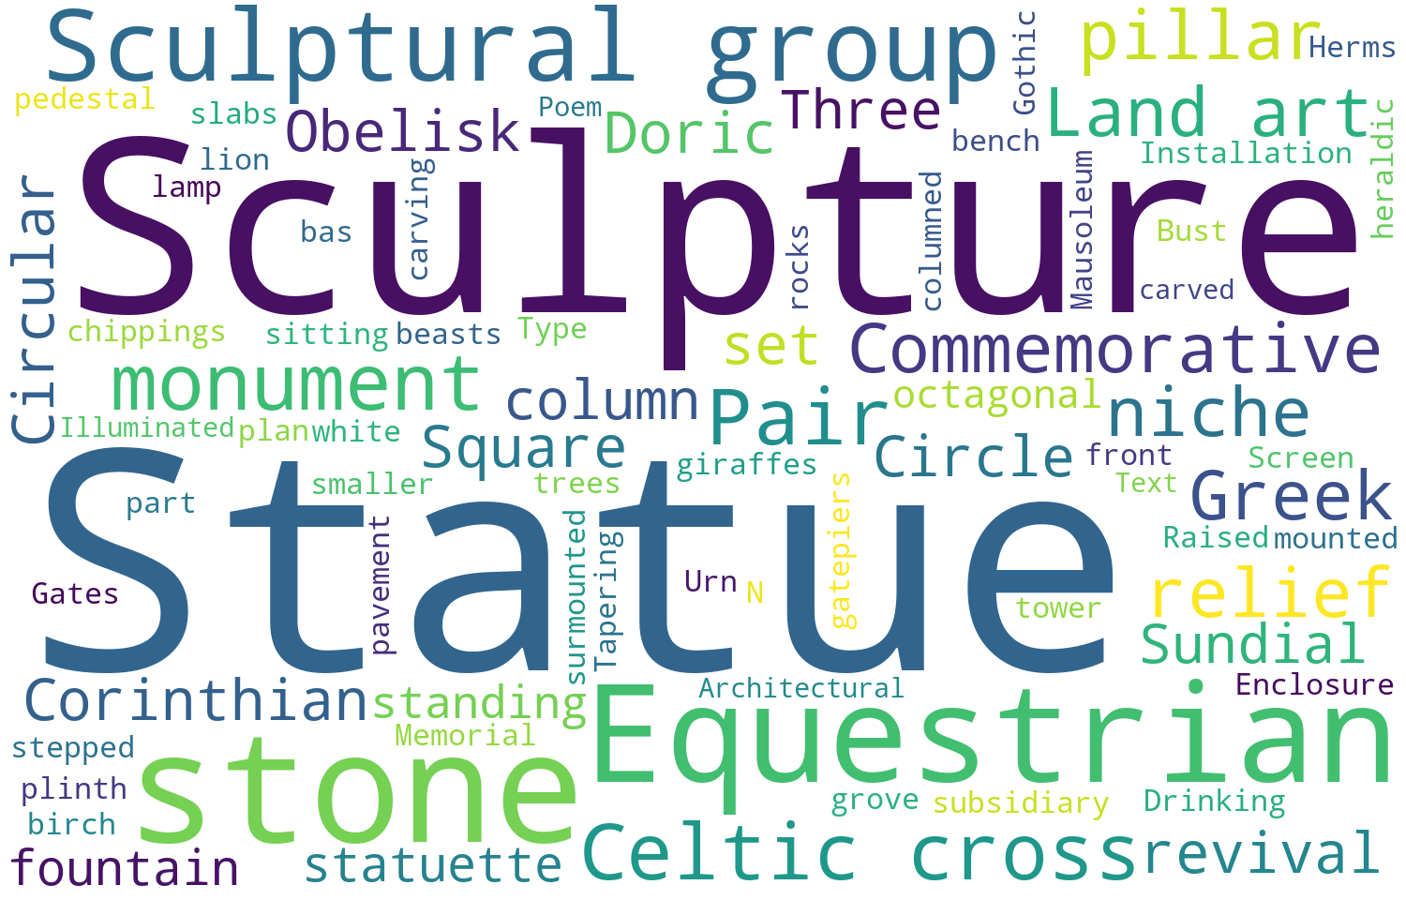

总结：通过数据分析，我们发现（总结一下爱丁堡艺术品多，然后历史悠久），然后选择这个数据给我们的观众是有意义的，然后根据他的分布特点，由于大多数数据集中于市中心地区，我们将市中心单独选出，在整体介绍公共艺术时间分布和空间分布以外，通过实体地图和交互网页具体介绍此地区每个公共艺术品的情况。

（可能最后在report里图例要写一下嘻嘻）

（然后我不是发了一个评分表给你嘛，你康康怎么写能把这些点都包含嘞～～）